Activity 6. Hack your toys (ΝΕΜΟ)
- Learning outcome(s): (list up to 3)
    - Students learn the about the process of technical design.
    - Students learn how to design products using steps of designing.
    - Students learn to find opportunities in their surroundings for the development of possible products.
- Relation of activity with the STEM, gender inclusiveness and Entrepreneurship: (text, not bullets, explaining the relation of the activity to 3 above)
Students learn how to design products using steps of designing.
This activity helps students to become acquainted to designing products themselves and. By using the steps in the designing cycle they will be able to come up with ideas for products on their own, develop skills that require making a product and they will learn how to test their product, recognize problems and solve these problems. They will learn that in the process of designing, teamwork is an important factor, and that the diversity of a team will contribute to a diversity of outcomes. It makes a connection to real life design process and will help them develop the skills needed to take on (technical) problems and how to aim for providing a solution.
- Indicate the area of focus:
☒ STEM
☒ Gender inclusiveness
☒ Entrepreneurship
- Materials: (including ppts, videos, hands-on material)
- 16 playing cards
- 15 cm masking tape
- Old, unused toys that students bring from home
- Scissors
- Scotch tape
- Pipe cleaners (for craft)
- Iron wire
- Card board
- Markers
- String or wool
- Small sticks (popsicle sticks or other (wooden) sticks)
- Paper or plastic cups
- Rubber bands
- Paper clips
- Extra: tools such as handsaw, hand drill
- Extra: electronics such as electrical wire, batteries, LED-lights, buzzers or a small engine.
- Preparation:
Make sure to ask students beforehand to bring some old toys that they no longer want to use. This activity has two parts, that do not necessarily have to be during the same lesson. Divide the class into groups of four students for the first part, divide the group into pairs in the second part of the activity. Make sure every group has access to the materials listed above.
- Duration: 150 minutes or two classes of 30 and 120 minutes (minutes)
- Target group: 12-18 (student age)
__________________________________________________________________________

- Description of the activity:
Part I: House of Cards
Only use playing cards and tape for this activity. Students start with an activity to get acquainted to the idea of designing and problem solving. Every group has 16 playing cards and is asked to build a house of cards that is at least 25 cm. They will have 20 minutes to build the house of cards, which may either be a classical house of cards or something completely new. After building their house of cards, the students are asked to write down in verbs what steps they took in the process (e.g. asking questions, building, failing, testing, adding improvements). Give every group a minute to explain their outcome at the end of class. What problems did they find while building the card house. How did they solve these problems?
After building, shortly discuss the steps that the students took to make their house of cards. Explain that all the words they have written down are words we can fit inside the process of designing:
Problem - Explore - Design - Make - Test and improve

Part II: Hack your toys
Part II can either be done right after the house of card assignment or can take place during different lesson.
Make sure to ask students some days before the activity to bring some old toys to school that they will not use again. Students are divided into groups and the problem is presented.
Problem: In Europe, many children throw away their toys as soon as they do not want to play with them anymore. That is a waste of material, a lot of energy was put into the design and the manufacturing of these toys and it seems wrong to just throw it out when we have had enough. Surely there must be a better solution.
Tell students that they are about to design a new life for their old toys: hack your toys! The word 'hacking' is often used when talking about hacking computers, but a broader meaning of the word 'hack' is 'use for something that it was not intended for'. By hacking their toys they will give these discarded products a new life with possibly a different function.
By hacking their toys students will use the steps for designing:
Problem - Explore - Design - Make - Test and Improve
Explore (20 minutes)
Students take 20 minutes to explore the problem and the materials they are allowed to use. They will have time to discuss what they want to make and which materials they get to use.
Design (15 minutes)
Give students a sheet of A3 paper. They can use it to draw their design in detail and discuss how they are going to build the new product. As a teacher, ask critical questions and make sure that the new parts of their design are not only their for aesthetic reasons but actually have a (technical) function. Make sure that the students know they are allowed to start building only when the teacher has approved of the design.

Make (35 minutes)
In the next step students will build their new design. They use their old toy and the materials to create a new product. Walk around between the groups and provide help where needed.
Test and improve (20 minutes)
In this step students have most likely found some problems with their design, or some features that can be improved. They use the materials to improve their design. Does the new product still have the new functions they intended? Help students with testing and provide tips for improvement.
Suggestions for supervising student's design process:
- Give hints, but also ask a lot of questions and help them find the answers on their own.
- Listen, be supportive and show interest in their design.
- Tell students when they are doing a good job
- Make sure students keep their working place organized

Finishing up (15 minutes)
Have every pair present their product to their classmates. Give them some time to explain their product and its functions. Ask questions, such as
- What did they make?
- What were they thinking of while making the design?
- On what points does the final product differ from the design?
- What kind of improvements did they make while building?

Also ask questions that help students to put their design in an entrepreneurial context.
- Does your invention have a value for a specific target group (customers)? Which is
this target group?
- How would you be able to use your invention or your knowledge to make a living?
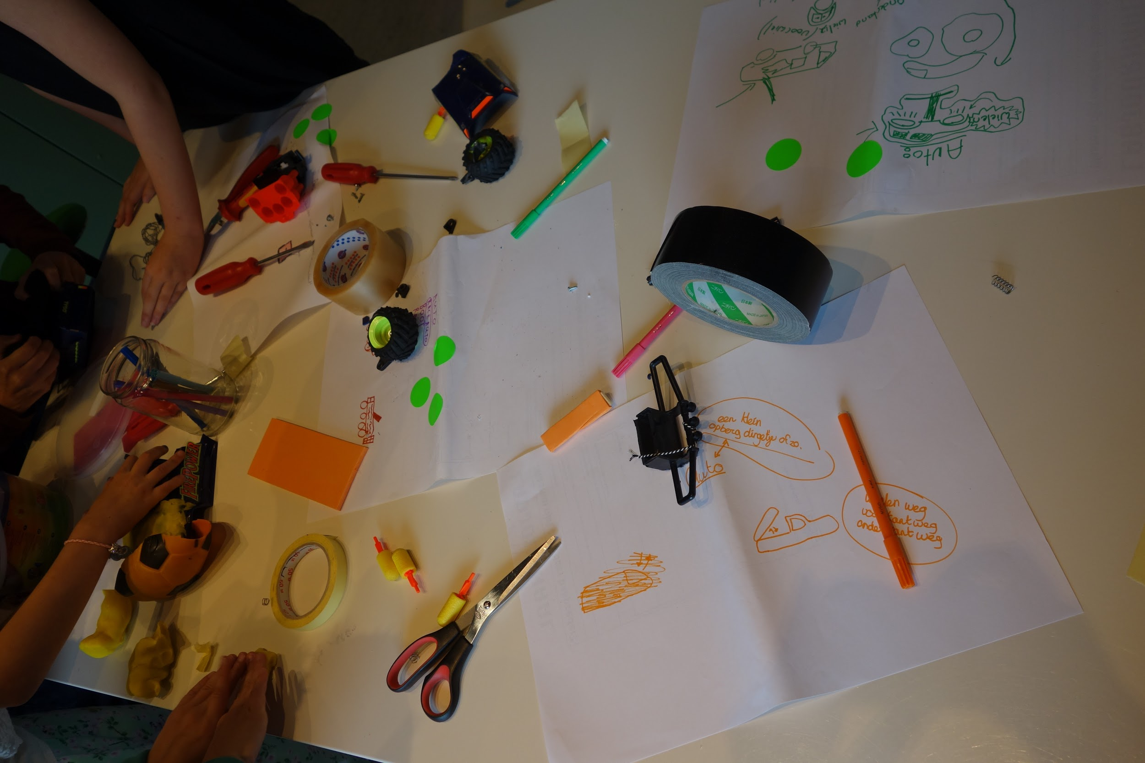

9. Link to curriculum: engineering and design

