Activity 27. Coding and Startups (CYRIC)
- Learning outcome(s): (list up to 3)
    - Raise awareness of entrepreneurial career paths based on digital technologies like Coding.
    - Develop digital skills like coding and computational thinking.
- Relation of activity with the STEM, gender inclusiveness and Entrepreneurship: (text, not bullets, explaining the relation of the activity to 3 above)
Regarding entrepreneurship, the activity exposes students to the qualities and lifestyle of an entrepreneur, focusing on young founders of local startups. The relation with STEM is clear, since coding and computational thinking are key abilities of it and several technical co-founders have them. In terms of gender inclusiveness, teachers can also select startups with female founders, to promote entrepreneurship as a natural path for girls as well.
- Indicate the area of focus:
☒ STEM
☐ Gender inclusiveness
☒ Entrepreneurship
- Materials: (including ppts, videos, hands-on material)
- None
- Preparation:
Teachers review the availability of Startups and young companies in their vicinity and arrange a visit ahead of time. Depending on location and language restrictions, teleconferences can also be arranged.
- Duration: 60-80 (minutes)
- Target group: 12-15 (student age)
__________________________________________________________________________

- Description of the activity:
The teacher and students visit local STEM/Tech Startups (via STEMitUP) or connect via teleconference with a Startup. The Startup founders share their experiences and their relation to STEM if any, to inspire and raise awareness, as well as make Digital/Tech careers more attractive. Emphasis is placed on people, particularly allowing enough time for students to listen to founders’ experiences and ask questions.

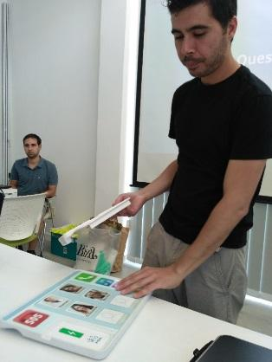
9. Link to curriculum: Computing/Informatics Module

